29.11: 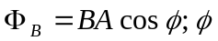 is the angle between the normal to the loop and 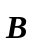, so 